**TITLE : Real time os security event logger**

INTRODUCTION TO OPERATING SYSTEM :

**1.Introduction**

An Operating System (OS) is system software that acts as an intermediary between computer hardware and users. It provides a platform for executing applications and managing hardware resources efficiently. The primary goal of an operating system is to make computing convenient for users while ensuring efficient use of hardware.

**2.History of Operating Systems**

Operating systems have evolved significantly over time. Initially, computers operated without an OS, requiring users to interact directly with hardware using machine language. In the 1950s and 1960s, batch processing systems emerged, allowing multiple jobs to be executed sequentially. The development of time-sharing systems in the 1960s enabled multiple users to interact with a single system simultaneously. With the advent of microcomputers in the 1980s, personal computer operating systems like MS-DOS, Windows, and macOS became widespread. Today, operating systems power everything from smartphones to supercomputers.

**3.Functions of an Operating System**

An operating system performs several critical functions, including:

**3.1 Process Management**

* The OS handles process creation, execution, and termination.
* It manages CPU scheduling, allowing multiple processes to run efficiently.
* It ensures synchronization and communication between processes.

**3.2 Memory Management**

* The OS allocates and deallocates memory to processes as needed.
* It uses techniques like paging and segmentation for efficient memory utilization.
* Virtual memory allows programs to execute even if RAM is insufficient.

**3.3 File System Management**

* The OS organizes, stores, retrieves, and manages files on storage devices.
* It provides access control and permissions to ensure data security.
* Common file systems include NTFS, FAT, and ext4.

**3.4 Device Management**

* The OS controls hardware devices through drivers.
* It ensures smooth communication between the system and peripherals like printers, keyboards, and disk drives.
* Device queues and buffering improve performance.

**3.5 User Interface**

* Operating systems provide command-line interfaces (CLI) and graphical user interfaces (GUI) for user interaction.
* Examples include the Windows GUI, macOS GUI, and Linux terminal.

**4. Types of Operating Systems**

Operating systems can be classified into different categories based on their functionalities and usage.

**4.1 Batch Operating System**

* Executes a batch of jobs sequentially without user interaction.
* Used in early mainframe computers.
* Example: IBM OS/360.

**4.2 Time-Sharing Operating System**

* Allows multiple users to share system resources simultaneously.
* Ensures fair CPU allocation through scheduling algorithms.
* Example: UNIX.

**4.3 Distributed Operating System**

* Manages a group of computers connected over a network.
* Distributes processing across multiple machines for efficiency.
* Example: Amoeba, Windows Server.

**4.4 Real-Time Operating System (RTOS)**

* Processes data in real-time with minimal delay.
* Used in embedded systems, robotics, and industrial automation.
* Example: VxWorks, FreeRTOS.

**4.5 Network Operating System (NOS)**

* Provides networking capabilities for managing computers in a network.
* Supports file sharing, remote access, and network security.
* Example: Novell NetWare, Windows Server.

**4.6 Mobile Operating System**

* Designed for smartphones and tablets.
* Optimized for touch interactions and power efficiency.
* Example: Android, iOS.

**5. Popular Operating Systems**

Several operating systems are widely used across various platforms:

* **Windows:** Developed by Microsoft, known for its user-friendly interface and widespread usage.
* **Linux:** Open-source OS known for security, flexibility, and customization.
* **macOS:** Apple's proprietary OS known for its smooth UI and integration with Apple hardware.
* **Unix:** A multi-user OS used in servers and workstations.
* **Android:** Mobile OS based on Linux, developed by Google.
* **iOS:** Apple's mobile OS known for security and performance.

**6. Conclusion**

Operating systems are the backbone of modern computing, enabling seamless interaction between users and hardware. With continuous advancements, operating systems are becoming more sophisticated, incorporating artificial intelligence, cloud computing, and enhanced security features. Understanding the fundamentals of OS is essential for computer science students and IT professionals alike.

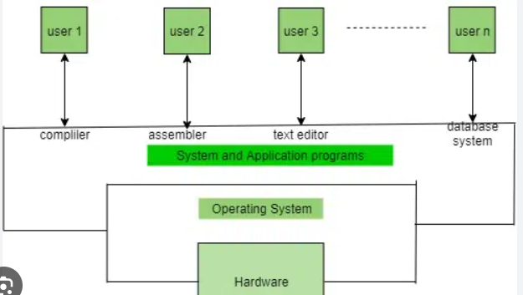

7. INTRODUCTION TO PROJECT :

**Real-Time OS Security Event Logger**

The purpose of this project is to develop a Page Replacement Algorithm Simulator that demonstrates the working and efficiency of various page replacement strategies used in memory management. The simulator provides an interactive way to analyze and compare different algorithms based on parameters such as page fault rate and memory utilization efficiency. The project aims to enhance understanding of operating system memory management techniques and their impact on system performance.

**7.1. Introduction**

A **Real-Time OS Security Event Logger** is a software tool designed to monitor, record, and analyze security-related events in an operating system. The primary goal of this logger is to track system activities in real-time, detect potential security threats, and provide detailed logs for analysis. This is crucial for maintaining system integrity, as operating systems must handle unauthorized access, privilege changes, and suspicious activities efficiently to prevent security breaches.

**7.2 Understanding Real-Time OS Security Event Logging**

In an operating system, security threats can arise from unauthorized access, privilege escalations, or malicious activities. A **Real-Time OS Security Event Logger** continuously monitors system events, capturing critical security-related activities to detect and prevent potential breaches. It helps identify suspicious behavior, such as failed login attempts or unauthorized modifications, allowing administrators to respond swiftly.

The **Real-Time OS Security Event Logger** provides insights into system security by analyzing event patterns and alerting users to anomalies. This ensures better protection of system resources and enhances overall security management.

### ****7.3 Features of a Real-Time OS Security Event Logger****

* **User Interface:** A GUI or CLI for monitoring security events.
* **Real-Time Monitoring:** Tracks login attempts, file changes, and privilege modifications.
* **Event Logging:** Records security-related activities with timestamps for auditing.
* **Alert System:** Sends notifications for suspicious behavior.
* **Performance Analysis:** Detects patterns and assesses system vulnerabilities.

**7.4. Objectives of the Project**

* **Real-Time Monitoring:** Continuously track and log security-related events in the operating system.
* **Threat Detection:** Identify unauthorized access attempts, privilege escalations, and suspicious activities.
* **Efficient Logging:** Maintain detailed records of security incidents for auditing and analysis.
* **User Alerts:** Notify administrators about potential security threats in real time.
* **Data Analysis:** Provide insights into security trends and vulnerabilities.
* **Improved Security Management:** Enhance system security by enabling quick response to threats.

### ****7.5 Literature Review****

#### ****7.5.1 Background of Real-Time OS Security Event Logging****

* Security event logging is essential for monitoring system activities and detecting potential threats in real-time.
* An efficient logging system helps in identifying unauthorized access, privilege changes, and malicious actions to ensure system integrity.
* Real-time monitoring enhances security by allowing immediate threat detection and response.

#### ****7.5.2 Existing Work and Methods****

* Various security event logging systems exist, including Syslog, Windows Event Viewer, and SIEM (Security Information and Event Management) solutions.
* Research suggests that **real-time monitoring with AI-driven anomaly detection** improves threat detection but requires significant computational resources.
* Lightweight logging mechanisms like **auditd** in Linux provide a balance between performance and system overhead.

### ****7.6 System Design and Implementation****

#### ****7.6.1 System Requirements****

* **Hardware:**
  + Minimum **4GB RAM**, 64-bit processor.
  + Sufficient storage space for event logs and security records.
* **Software:**
  + **Programming Languages:** Python, C++, or Java.
  + **Logging Frameworks:** Linux **auditd**, Syslog, or Windows Event Viewer.
  + **Database:** SQLite/MySQL for storing security logs.
  + **Visualization & Analysis:** Matplotlib, Pandas for graphical representation of logs.
  + **GUI Libraries:** Tkinter/PyQt for an interactive interface.
* **Operating System:**
  + Compatible with **Windows, Linux, and macOS** for cross-platform functionality.

**7.6.2 Architecture of the Simulator**

**Flowchart of the Simulator Architecture:**

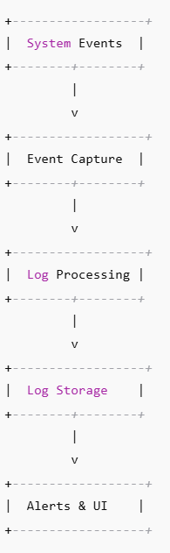

### ****7.6.3 Implementation of Real-Time OS Security Event Logger****

#### ****6.3.1 Event Logging using FIFO (First-In-First-Out)****

* The oldest logged event is removed first when the log storage reaches its limit.
* Simple but inefficient as it does not consider event severity or frequency of occurrence.
* **Diagram:**

Log Storage:

[Event1] [Event2] [Event3]

New Event4 arrives -> Oldest (Event1) is removed -> [Event2] [Event3] [Event4]

**6.3.2 Least Recently Used (LRU)**

• Removes the log entry that has not been accessed for the longest time.

• More efficient than FIFO but requires tracking log access timestamps.

* **Diagram:**

Access History:

[Login] [File Access] [Process Start]

New Event (Network Activity) -> Remove least recently accessed -> [File Access] [Process Start] [Network Activity]

**6.3.3 Optimal Logging (Predictive Log Management)**

• Removes the log entry that will be needed the farthest in the future.

• Most efficient but requires prior knowledge of security event patterns.

* **Diagram:**

Future Reference:

[Failed Login] [File Access] [Network Alert]

New Event arrives -> Remove log that will be least relevant in future

**6.3.4 Least Frequently Used (LFU) Logging**

* Removes the log entry that occurs the least number of times.
* Works well for repetitive security threats but may retain outdated logs.
* **Diagram:**

Log Frequency:

[Login (1x)] [File Access (2x)] [Malware Alert (3x)]

New Event Arrives -> Remove least frequent log (Login)

### 6.3.5 ****Clock (Second Chance) Algorithm for Logging****

* An improvement over FIFO that prioritizes logs with higher importance.
* Uses a circular queue to efficiently manage logs.
* If an event has a **"high priority"** flag, it gets a second chance before removal.
* **Diagram:**

Log Storage with Priority:

[Event1] (flag=1) [Event2] (flag=0) [Event3] (flag=1)

Clock hand moves -> Removes [Event2] (flag=0)

**7.7. Simulation Results and Analysis**

• **Input:** User provides security event logs and storage capacity.

• **Processing:** The system applies logging strategies to decide which logs to retain or discard.

* **Output:** Log retention efficiency, alert accuracy, and storage optimization.
* **Graphical Representation:**
* Comparison of Security Event Log Retention Efficiency and Processing Time

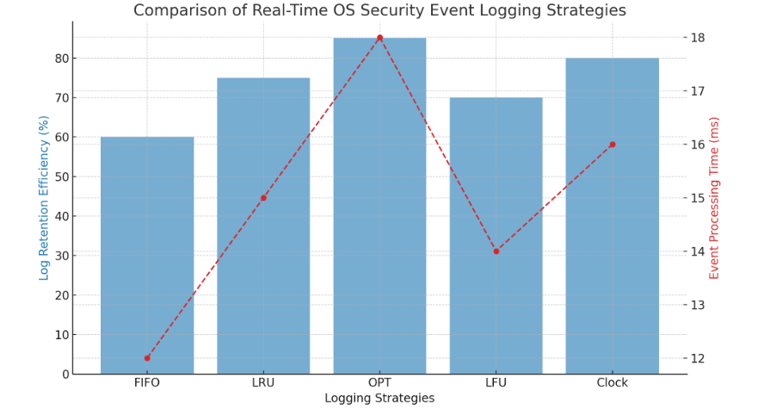

**7.8. Challenges Faced & Solutions**

**7.8.1 Challenges**

* **High Log Volume:** Managing a large number of security events in real time without data loss.
* **Efficient Storage:** Ensuring critical logs are retained while avoiding unnecessary data accumulation.
* **Real-Time Processing:** Detecting and analyzing security threats without causing system slowdowns.
* **Visualization Complexity:** Displaying log trends and security breaches effectively.

**7.8.2 Solutions**

• **Optimized Data Handling:** Used efficient data structures like queues and hash maps for quick access.

• **Storage Management:** Implemented log rotation and compression techniques to balance storage and accessibility.

• **Parallel Processing:** Utilized multithreading to process security events in real time without system lag.

• **Graphical Representation:** Used lightweight libraries for real-time visualization of security alerts

**7.9. Future Scope**

* **AI-Driven Threat Detection:** Implementing machine learning models to predict and prevent security breaches.
* **Cloud Integration:** Enhancing security event logging for distributed and cloud-based operating systems.
* **Automated Incident Response:** Developing self-healing mechanisms to counter detected threats in real time.
* **Advanced Data Visualization:** Implementing 3D graphical representations for improved analysis of security events.
* **7.10. Applications of the Security Event Logger**

• **Cybersecurity Monitoring:** Helps security analysts track and respond to real-time threats in an OS.

• **Compliance Auditing:** Ensures organizations meet security standards by maintaining a detailed log of system events.

• **Forensics & Investigation:** Assists in identifying unauthorized access and system vulnerabilities.

• **Operating System Development:** Aids in designing secure OS architectures by analyzing real-time security threats.

**7.11.NEED FOR THIS :**

The **Real-Time OS Security Event Logger** was developed to address key challenges in system security and event monitoring. Here’s why it is essential:

1. **Real-Time Threat Detection:** Traditional logging methods fail to detect security breaches instantly, increasing system vulnerability.
2. **Efficient Log Management:** Large volumes of security events can overwhelm storage and processing capabilities without proper optimization.
3. **Lack of Centralized Monitoring:** Security incidents across different system components need a unified logging system for better analysis.
4. **Compliance & Auditing Needs:** Organizations require proper event logs to meet regulatory and security standards.
5. **Automated Response & Forensics:** Helps security professionals analyze past incidents, detect attack patterns, and improve future security measures.

This ensures **enhanced system security, real-time monitoring, and efficient threat management.**

**7.12. Conclusion**

The **Real-Time OS Security Event Logger** plays a crucial role in modern system security by providing **real-time monitoring, threat detection, and efficient log management**. It enhances system integrity by ensuring that security breaches, unauthorized access, and anomalies are promptly detected and logged for further analysis.

By integrating **automated response mechanisms, centralized log management, and compliance tracking**, this system helps organizations **strengthen cybersecurity, improve forensic analysis, and meet regulatory requirements**. Future advancements, such as **AI-driven threat prediction and cloud-based log management**, will further enhance its capabilities, making it an essential tool for securing real-time operating systems.

This project demonstrates the **importance of proactive security event logging in protecting digital infrastructures** and **ensuring the reliability and safety of modern computing environments**.